DATA 301 Lab September 23rd

Lab 1

* Labs are NOT going to be recorded
* Everthing you do should be “automatic”, no manual imputing of data (i.e. copy/paste)
* Access github account
  + Clone to local system
* Create new sheet (“data”)
  + Don’t copy/paste
  + Instead—type =rawdata(A1) and click and drag
  + =rawdataA2 + click and drag horizontally and vertically
  + If function
    - Do in separate tab
    - =if(OR(D2>0, D2<=100
    - =if(isnumber
    - 

Timestamp

* Separate date and time
  + Convert to formats
  + Then put back together
* to separate – paste separate in new tabs
* to change date—datevalue(“fomat moosvi wants”)
* =time(“oo”, “oo”, “oo”) for time
* Then combine both
* =mid
* 
* Explain mid function
* Grab time-- =mid(12,8
* 
* More number formats –Custom—
* 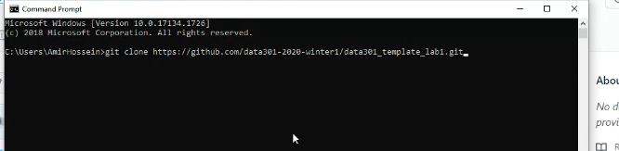



Create repository

* Push finished assignment to git repository and send link to Canvas
  + Watch Moosvi’s video
* don’t download zip file
  + gitclone(link of repository)
  + download Git to use git in command line
  + git bash (terminal) is encouraged
* =CountIF(range), “<>1”)
* -- for initial steps
* Timestamp—have separate cells for : date, hour, minute, second
  + “mid() + MID() + MID()”
  + Then convert using datevalue and time
  + Mid(D4, 9, 2) & “-“ MID(D4, 5,3))
  + 
* Transformation
  + No need for pivot table
  + Use IF statements and drag
  + 
  + -- for cleaning section
* To contact TA, use email or Canvas --- [zeinalik@mail.ubc.ca](mailto:zeinalik@mail.ubc.ca)
* =(MID(rawdata!A2, 5,3)& "-" & MID(rawdata!A2,9, 2)& "-"& RIGHT(rawdata!A2,4)) + TIME(MID(rawdata!A2, 12,2),MID(rawdata!A2,15,2),MID(rawdata!A2,18,2))

=pivot table – create new worksheet

= timestamp, value , global sensor id

* Put global id on columns, timestamp on rows
* 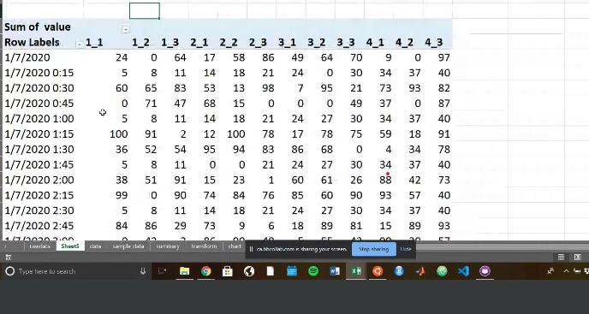
* 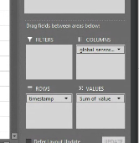

Lab 2

* Commands—LS= shows files in directory
  + Ls-l shows files as lists
  + Rwx – read/write/execute premissions (fyi, not a command)
  + Ls-lh – shows file sizes
  + Touch – create file
  + Cd = go inside directory
  + .. – goes back one folder
* Lab objectives – ls-f
  + \* = executable
  + Go through diff files and run them and run all files you come up with in directories
  + Pip install tree – installs tree (directory app)
  + 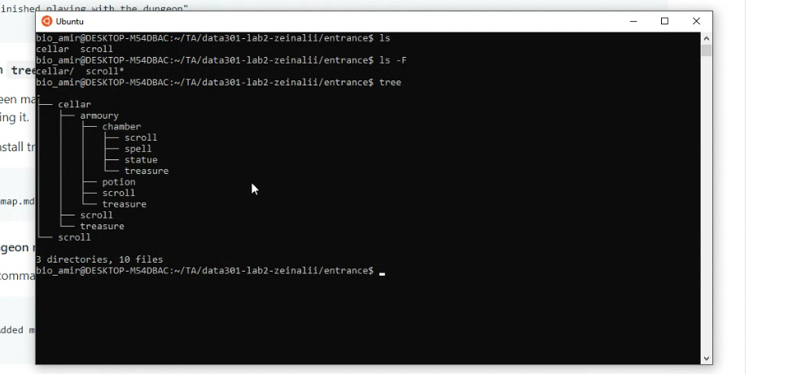
* How to save – tree > result.txt – file is saved into result.txt
  + To save w/o overwriting – tree >> result.txt – creates new save file w/o overwriting old one
* 
 